FOR NEWSLETTERS
Do you want little or no debt when you go to college? Visit payingforcollegesd.org to watch easy-to-follow videos designed to help you get the best return on your college investment and avoid costly mistakes. Find tips about budgeting, learn more about financial aid and student loans, and hear advice from South Dakotans like you.

This project is supported by a grant from the South Dakota Community Foundation.

Image Options

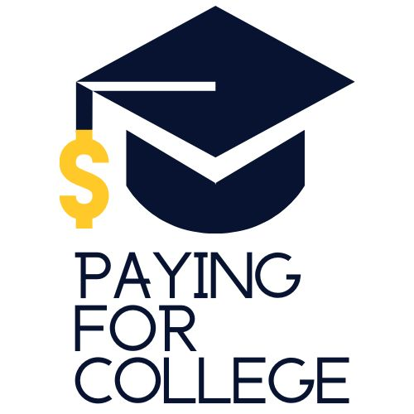
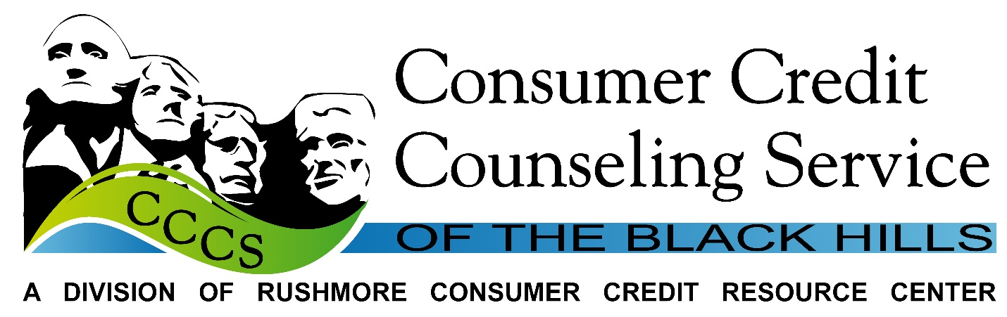
Partner Logos
